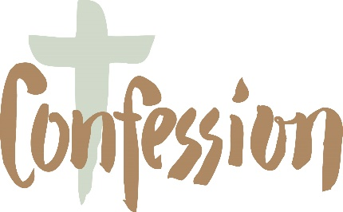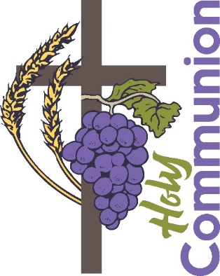
Go Seek Find: Reconciliation and Eucharist
The program uses a different approach which centers around not using a textbook or a workbook, children interact with and explore the Catholic Children’s Bible and track their journey to the destination of celebrating the Sacrament using hands on activities, treasure maps, and stickers.

Please join us on November 20, 2022 after the 10:30am Mass. This gathering is for a parent and your child and will last one hour. Please know that we are recommending that the family should be attending Mass as your child is preparing for their Sacraments. The Eucharist is the center of our Faith. So, we are encouraging your family to go to 10:30am Mass and meet for the gathering after Mass.
Calendar

Sunday, November 20, 2022 Child and parent gathering
Sunday, December 18, 2022 Child and parent gathering

Sunday, January 22, 2023 Child and parent gathering
Sunday, February 26, 2023 Child and parent gathering
Sunday, March 19, 2023 Child and parent gathering
Sunday, April 16, 2023 Child and parent gathering
Saturday, April 29, 2023 Retreat 9am to 12pm
First Reconciliation 11am

Sunday, May 7, 2023 May Crowning at 10:30am Mass

